Joint Planning Support Element
Joint Planners Course
Administrative Information and Instructions

The following provides information on administrative requirements for the Joint Planning Support Element’s (JPSE) Joint Planners Course (JPC):
- Course lead instructor: Mr. Andrew Creel; Phone: (757) 278-6829, DSN (322) 278-6829; E-mail address: andrew.p.creel.civ@mail.mil
- Course instructor: Mr. JR Jones; Phone: (757) 278-6844, DSN (322) 278-6844; E-mail address: johnny.r.jones50.civ@mail.mil
- Course coordinator: Mr. Renwick Lane; Phone: (757) 278-6837, DSN (322) 278-6837; Email address: renwick.r.lane.ctr@mail.mil

- STUDENT BIOGRAPHY INFORMATION:
  - If you did not previously submit a JPC Student Biography form or you have changes to your previously submitted Student Biography, you need to do this now. This form will be used to place attendees into planning teams based on their skill sets and experiences. Save the form using the following naming convention and send to me: “LastName_FirstName_StudentBio”.

- ACCESS TO BASE:
  - Credentials that allow access to the installation are the Common Access Card (CAC), Military retiree ID card, Dependent ID Card, DoD-issued Civilian (Non-CAC) ID card (including non-appropriated), Non-DOD Federal Person Identity Verification including those issued by Department of Homeland Security.
  - Do not bring personally owned firearms or ammunition on to base!

- FIRST DAY ARRIVAL LOCATION AND TIME:
  - Initial check-in on Day 1 will start at 0800 at the Marianas Hall 2nd floor “Azalea Room”. Enter through the Navy Gateway Inns & Suites (NGIS) ramp just right of the main entrance. Follow signs upstairs to the conference rooms. Parking can be found in front of the facility.

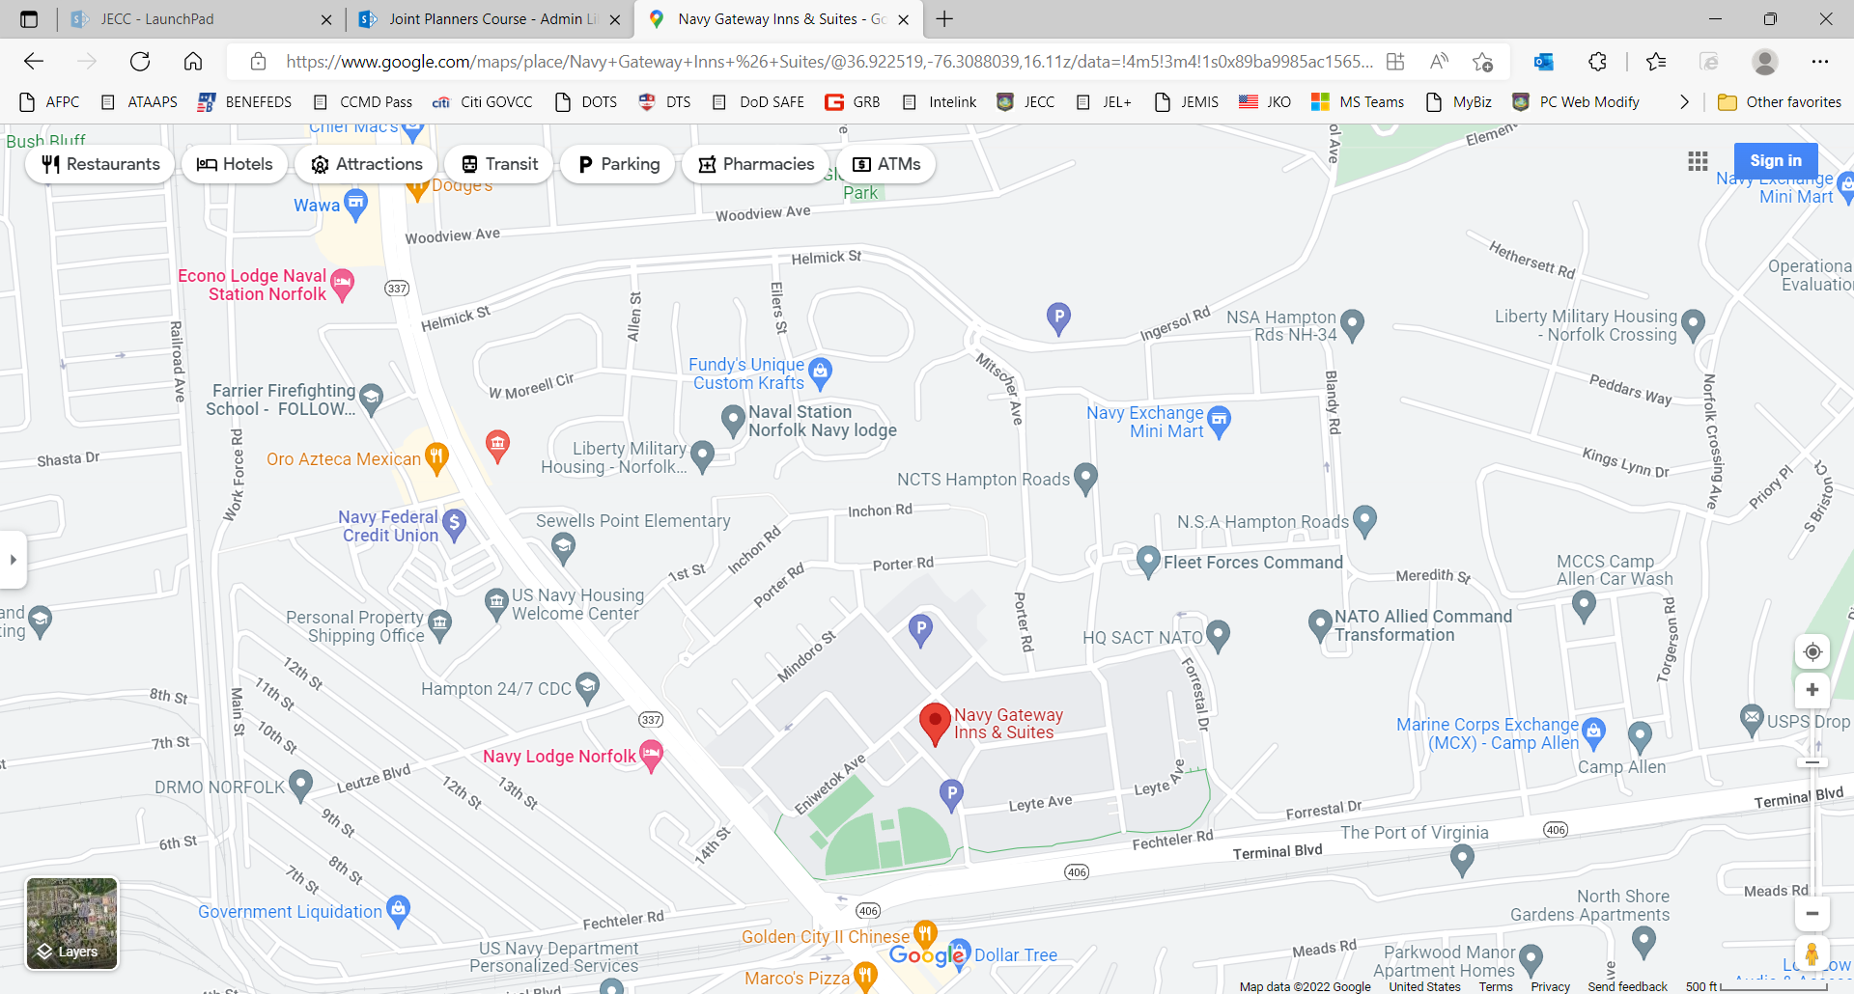
Hampton Blvd
Terminal Blvd

Base Entrance
  - Enter Naval Support Activity (NSA) Norfolk at either the Meredith St gate near the Marine Corps Exchange (MCX) on Terminal Blvd or enter through the Mitscher Ave gate on Helmick St. Marianas Hall is collocated with the Navy Gateway Inns & Suites at 7800 Hampton Blvd bldg. SC-400, Norfolk, VA 23511.

- CLASS NOTES:
  - JPC will be conducted on weekdays only from 0800 to 1700 in the Azalea Room of Marianas Hall (7800 Hampton Blvd bldg. SC-400, Norfolk, VA 23511).
  - This is a rigorous course that requires additional commitments outside of normal duty hours; to include group work and scheduled presentations during some lunch hours. The lunch hour is typically used by students to prepare or refine planning products. There are numerous fast-food restaurants nearby.
  - Day 1 we will have a No-host social at Elation Brewery: 5104 Colley Ave, Norfolk, VA 23508.
  - For JPSE personnel, JPC is your assigned place of duty. Refrain from making any appointments that interfere with your daily attendance.

- SECURITY NOTE:
  - Though this is an UNCLASSIFIED course we do ask that all personal electronic devices be left in a trusted location. We will set up a table just outside the class where you may leave your devices, so you may have easy access to them during breaks.
  - Personal and government laptops cannot be used on our network for this course.
Removable Media Policy
Not Authorized on USTRANSCOM Systems / Networks

- Memory Sticks
- Thumb Drives
- Camera Flash Media Cards
- IPODS, MP3’s, Music CD’s
- Transfer of data between classified systems

Do not bring any devices, including US Government laptops.
You will be provided with a lap top computer with visitor access.

- UNIFORM:
  - Military – Authorized JECC duty uniform, utilities or equivalent will be the normal uniform for the course, unless Service specific uniform policies direct. Flight suits may be worn as authorized by Service regulations.
  - Civilian – Business casual.

- LODGING AND TRAVEL:
  - Navy Lodge Norfolk – 2 miles / 7-minute drive to Marianas Hall. Just off base, closest to base entrance. Navy Lodge Norfolk: Navy and Military PCS Housing, Norfolk, VA USA (navy-lodge.com)
  - Hampton Inn Norfolk – 2.8 miles / 11-minute drive to Marianas Hall
Hotels near Norfolk Airport - Hampton Inn Norfolk-Naval Base (hilton.com)
  - Navy Gateway Inns & Suites – 0 miles / 2-minute walk inside Marianas Hall. Collocated with Marianas Hall. Navy Hotels for TDY and Leisure Lodging -- Navy Gateway Inns & Suites (dodlodging.net)
  - If you find lodging off base, please expect heavy traffic in the mornings and plan accordingly.
  - The closest airport is Norfolk International Airport (ORF). You may also find flights into Newport News/Williamsburg Airport (PHF).
  - Note to JPSE RC personnel: You need to coordinate your orders and DTS travel through your Reserve Element and RIO.
  - NOTE: When you are making your return flight arrangements, please take into consideration that the final day (Day 10) will go until 1200. Graduation starts at 1130. Please do not expect to leave any earlier if you want to receive credit for attending the course.

- JPC REQUIRED PREPARATORY READINGS:
  - The following joint publications are designed to help prepare students for JPC. Read means JPC students have a Bloom’s Taxonomy “Understanding” of the material – they can describe and explain the content. Review means JPC students have a Bloom’s taxonomy “Knowledge” of the material – they have a working understanding and can find the details in the source document if required. Skim means JPC students have a general idea of what topics the source document covers.
    - Read: JP 5-0, Joint Planning, 01 December 2020, Chapters III and IV.
    - Review: JP 1, Volume 1, Joint Warfighting, 29 June 2020 – Focus on chapter III.
    - Review: JP 1, Volume 2, The Joint Force, 19 June 2020 – Focus on chapters III and IV.
    - Review: JP 3-0, Joint Campaigns and Operations, 18 June 2022 – Focus on Chapters II, III, and IV.
    - Skim: JP 3-33, Joint Force Headquarters, 09 June 2022.

  - The above joint doctrinal publications can be found on the JEL+ (restricted / CAC enabled) website at: https://jdeis.js.mil/jdeis/generic.jsp
  - They may also be found in the public domain on the Joint Chiefs of Staff webpage at: https://www.jcs.mil/Doctrine/Joint-Doctine-Pubs/
  - Note: if the links do not work, copy, and paste the URL into your browser.

